Solution to Task 1: -

1. example.net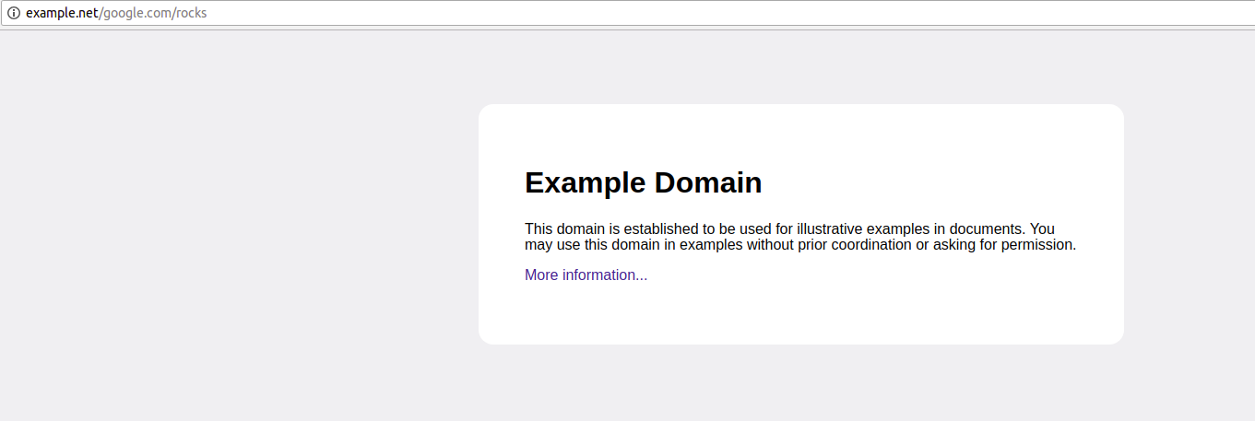
2. 
3. Web services work on port 80. Even-though http is mentioned, its because the basic configuration is done through this port for web services, it shall pass through the SSL layer, making it https.